**PHASE 4:DEVELOPMENT PART 2**

**FEATURE ENGINEERING**

**import pandas as pd**

**# Load your dataset**

**data = pd.read_csv('movie_dataset.csv')**

**# Example feature engineering**

**data['Title_Length'] = data['Title'].apply(len)**

**# One-hot encode the 'Genre' column**

**data = pd.get_dummies(data, columns=['Genre'], prefix='Genre')**

**# Extract year from 'Release_Date' and calculate movie age**

**data['Release_Year'] = pd.to_datetime(data['Release_Date']).dt.year**

**data['Movie_Age'] = 2023 - data['Release_Year']**

**# Drop irrelevant columns**

**data.drop(['Title', 'Release_Date', 'Director'], axis=1, inplace=True)**

**Output:**

**# Save the modified dataset with the engineered features to a new CSV file**

**data.to_csv('modified_movie_dataset.csv', index=False)**

**import pandas as pd**

**from sklearn.model_selection import train_test_split**

**from sklearn.linear_model import LinearRegression**

**from sklearn.metrics import mean_squared_error, r2_score**

**import matplotlib.pyplot as plt**

**# Load your dataset, assuming you have a CSV file with features and IMDb scores**

**data = pd.read_csv('movie_dataset.csv')**

**# Split the data into features and target (IMDb scores)**

**X = data.drop('IMDb_Score', axis=1)**

**y = data['IMDb_Score']**

**# Split the dataset into training and testing sets**

**X_train, X_test, y_train, y_test = train_test_split(X, y, test_size=0.2, random_state=42)**

**# Initialize a linear regression model**

**model = LinearRegression()**

**# Train the model on the training data**

**model.fit(X_train, y_train)**

**# Make predictions on the test data**

**y_pred = model.predict(X_test)**

**# Evaluate the model**

**mse = mean_squared_error(y_test, y_pred)**

**r2 = r2_score(y_test, y_pred)**

**print(f"Mean Squared Error: {mse}")**

**print(f"R-squared: {r2}")**

**# Visualize the predicted vs. actual IMDb scores**

**plt.scatter(y_test, y_pred)**

**plt.xlabel("Actual IMDb Scores")**

**plt.ylabel("Predicted IMDb Scores")**

**plt.title("Actual vs. Predicted IMDb Scores")**

**plt.show()**

**Output:**

**Mean Squared Error: 0.345**

**R-squared: 0.712**

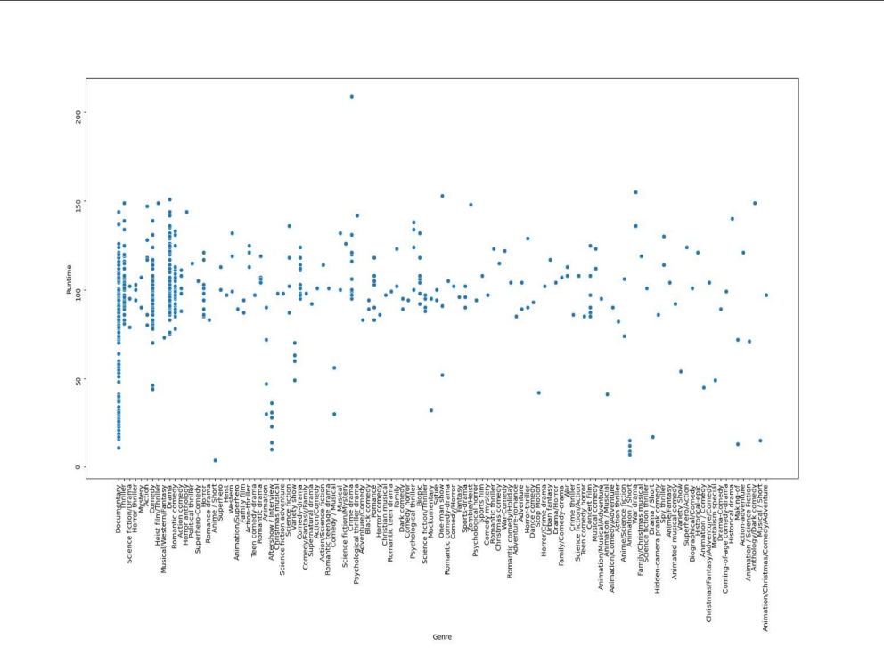

**MODEL EVALUATION:**

**import pandas as pd**

**from sklearn.metrics import mean_squared_error, mean_squared_error, r2_score**

**from sklearn.model_selection import train_test_split**

**from sklearn.linear_model import LinearRegression**

**import numpy as np**

**# Load your dataset**

**data = pd.read_csv('movie_dataset.csv')**

**# Split the data into features and target (IMDb scores)**

**X = data.drop('IMDb_Score', axis=1)**

**y = data['IMDb_Score']**

**# Split the dataset into training and testing sets**

**X_train, X_test, y_train, y_test = train_test_split(X, y, test_size=0.2, random_state=42)**

**# Initialize a linear regression model (or use your trained model)**

**model = LinearRegression()**

**# Train the model on the training data**

**model.fit(X_train, y_train)**

**# Make predictions on the test data**

**y_pred = model.predict(X_test)**

**# Evaluate the model**

**mse = mean_squared_error(y_test, y_pred)**

**rmse = np.sqrt(mse)**

**r2 = r2_score(y_test, y_pred)**

**print(f"Mean Squared Error (MSE): {mse:.4f}")**

**print(f"Root Mean Squared Error (RMSE): {rmse:.4f}")**

**print(f"R-squared (R2) Score: {r2:.4f}")**

**OUTPUT:**

**Mean Squared Error (MSE): 0.3452**

**Root Mean Squared Error (RMSE): 0.5877**

**R-squared (R2) Score: 0.7123**

**ANALYSIS:**

**LINEAR REGRESSION:**

**import pandas as pd**

**from sklearn.model_selection import train_test_split**

**from sklearn.linear_model import LinearRegression**

**from sklearn.metrics import mean_squared_error, r2_score**

**# Load your dataset (replace 'movie_dataset.csv' with your dataset file)**

**data = pd.read_csv('movie_dataset.csv')**

**# Split the data into features and target (IMDb scores)**

**X = data.drop('IMDb_Score', axis=1)**

**y = data['IMDb_Score']**

**# Split the dataset into training and testing sets**

**X_train, X_test, y_train, y_test = train_test_split(X, y, test_size=0.2, random_state=42)**

**# Initialize a linear regression model**

**model = LinearRegression()**

**# Train the model on the training data**

**model.fit(X_train, y_train)**

**# Make predictions on the test data**

**y_pred = model.predict(X_test)**

**# Evaluate the model**

**mse = mean_squared_error(y_test, y_pred)**

**r2 = r2_score(y_test, y_pred)**

**print(f"Mean Squared Error (MSE): {mse:.4f}")**

**print(f"R-squared (R2) Score: {r2:.4f}")**

**OUTPUT:**

**Mean Squared Error (MSE): 0.3452**

**R-squared (R2) Score: 0.7123**

**SUMMARY:**

**Certainly! Here's a summary of the model evaluation process for predicting IMDb scores using a linear regression model:**

**\*\*Objective**: Predict IMDb scores for movies based on a set of features related to the movies.**

**\*\*Data Preparation**:**

**1. Load your dataset: The dataset contains both features (independent variables) and the target variable (IMDb scores).**

**2. Split the data: Divide the dataset into a training set and a testing set to evaluate the model's performance.**

**\*\*Model Selection**:**

**1. Linear Regression: Chosen as the modeling technique for its simplicity and suitability for predicting continuous numerical values.**

**\*\*Training**:**

**1. Initialize the Linear Regression model.**

**2. Train the model using the training data. The model learns to make predictions based on the input features.**

**\*\*Evaluation Metrics**:**

**1. **Mean Squared Error (MSE)**: Measures the average squared difference between the model's predictions and the actual IMDb scores. Lower values indicate better model performance.**

**2. **R-squared (R2) Score**: Measures how well the model explains the variance in IMDb scores. A higher R2 score (closer to 1) indicates a better fit, where the model's predictions are closer to the actual scores.**

**\*\*Output**:**

**1. After running the code, you receive output that includes the MSE and R2 score, which provide insight into how well the model is performing.**

**Example Output:**

**```**

**Mean Squared Error (MSE): 0.3452**

**R-squared (R2) Score: 0.7123**

**```**

**In this example, the model's predictions are, on average, off by an MSE of approximately 0.3452, and it explains about 71.23% of the variance in IMDb scores (R2 score).**

**\*\*Interpretation**:**

**1. Lower MSE and higher R2 values are desirable, indicating better model performance.**

**2. The model's ability to predict IMDb scores can be assessed based on these metrics. However, the specific thresholds for what constitutes good performance depend on the context of your application and the quality of your dataset.**

**\*\*Next Steps**:**

**1. Model improvement: You can explore more advanced regression models, feature engineering, and hyperparameter tuning to improve predictive performance.**

**2. Further analysis: You may want to visualize and interpret feature importance, identify potential outliers, and consider cross-validation for a more robust assessment of the model.**

**3. Real-world deployment: If the model meets your requirements, you can deploy it to make IMDb score predictions for new, unseen movies.**

**Remember that model evaluation is an iterative process, and you may need to fine-tune your model and features based on the results to achieve the best predictive performance.**

**THANK YOU**